**INTRODUCTION TO JAVA:**

1. **PROGRAM:**

public class sample {  
  
 public static void main(String[] args) {  
 int a = 30;  
 int b = 10;  
 int c = 15;  
 int d = 20;  
  
 int ab = a + b;  
 int cd = c + d;  
 if(ab > cd){  
  
 System.*out*.println(true);  
 System.*out*.println("The sum of a + b = " + ab + " is greater than sum of c + d = " + cd );  
 }  
  
 else{  
 System.*out*.println(false);  
 }  
  
 }  
}

**OUTPUT:**

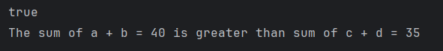

1. **PROGRAM:**

public class sample {  
  
 public static void main(String[] args) {  
 int a = 30;  
  
 if(a % 2 == 0){  
  
 System.*out*.println("The number " + 30 + " is a Even number");  
 }  
  
 else{  
 System.*out*.println("Not a even number");  
 }  
 }  
}

**OUTPUT:**

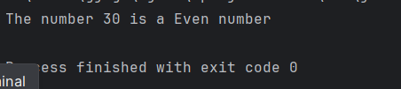

1. **PROGRAM:**

public class sample {  
  
 public static void main(String[] args) {  
  
 for(char i = 'A'; i <='Z'; i++){  
 System.*out*.print(i + " ");  
 }  
 }  
}

**OUTPUT:**

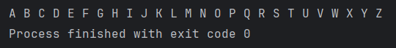

1. **PROGRAM:**

import java.util.Scanner;  
public class sample {  
  
 public static void main(String[] args) {  
 Scanner sc = new Scanner(System.*in*);  
  
 System.*out*.println("Enter number [a] = ");  
 int a = sc.nextInt();  
 System.*out*.println("Enter number [b] = ");  
 int b = sc.nextInt();  
  
  
 System.*out*.println("Before swapping: a = " + a);  
 System.*out*.println("Before swapping: b = " + b);  
  
 System.*out*.println("------------------------------");  
  
 int temp = a;  
 a = b;  
 b = temp;  
  
 System.*out*.println("After swapping: a = " + a);  
 System.*out*.println("After swapping: b = " + b);  
 }  
}

**OUTPUT:**

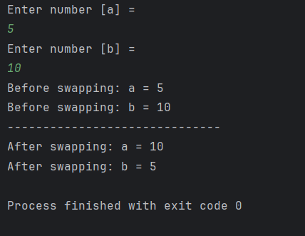

1. **PROGRAM:**

public class sample {  
  
 public static void main(String[] args) {  
  
 int a = 15;  
  
 if(a % 1 == 0 && a % a == 0) {  
  
 System.*out*.println("It [a = 15] is a PRIME number");  
 }  
  
 else{  
  
 System.*out*.println("Not a PRIME number");  
 }  
  
 }  
}

**OUTPUT:**

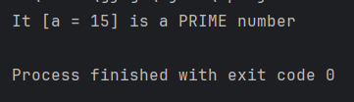

1. **PROGRAM:**

public class sample {  
  
 public static void main(String[] args) {  
  
 int n = 5;  
 int fact = 1;  
  
 for(int i=1;i<=n;i++){  
 fact = fact * i;  
 }  
  
 System.*out*.println("The factorial of " + n + " is : " + fact);  
 }  
}

**OUTPUT:**

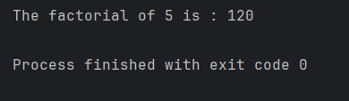

1. **PROGRAM:**

public class sample {

public static void main(String[] args) {

String str = "Guvi Geek";

int length =0;

for(char c : str.toCharArray()){

length++;

}

System.out.println("The length of the given string " + str + " is: " + length);

}

}

**OUTPUT:**

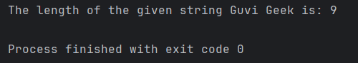

1. **PROGRAM:**

public class sample {  
  
 public static void main(String[] args) {  
  
 String str = "Welcome to Guvi";  
   
 for(int i = 1; i <= 10; i++){  
  
 System.*out*.println(str);  
 }  
 }  
}

**OUTPUT:**

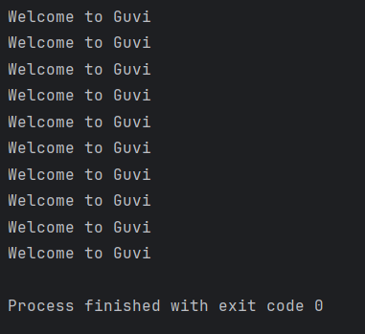

1. **PROGRAM:**

public class sample {  
  
 public static void main(String[] args) {  
  
 String name = "JEGAN";  
 int age = 22;  
   
 if(age >= 18){  
  
 System.*out*.println(name + " is a Senior Citizen");  
 }  
 else{  
 System.*out*.println(name + " is not a Senior Citizen");  
 }  
 }  
}

**OUTPUT:**

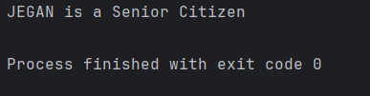

1. **PROGRAM:**

public class sample {  
  
 public static void main(String[] args) {  
  
 int number = 123;  
 int count = 0;  
 int temp = number;  
 if (temp == 0) {  
 count = 1;  
 } else {  
 while (temp > 0) {  
 temp = temp / 10;  
 count++;  
 }  
 }  
  
 System.*out*.println("The number of digits in " + number + " is: " + count);  
 }  
}

**OUTPUT:**

